|  |
| --- |
| REPORT |
| DL HOMEWORK-1 |
| RASHID ALI 0780819 |

|  |
| --- |
| Rashid Ali  11-5-2018 |

**DL HOMEWORK-1 REPORT**

**(1) Regression using Neural Network with 2 Hidden Layers**

**a)**

The training set and testing set are created by randomly assigning the 75% data samples to training set and 25% data samples to testing set. The categorical variables are converted into one-hot vectors. So, 15 features will be used for training.

Model parameters:

Epochs = 500

Learning Rate = 1e-05

Batch size =16

Network architecture: 15-10-10-1

Error function: Sum-of-squares error

Activate function: Sigmoid

Input dimension (576,15)

**b)**

1. Neural Network Architecture (Every input xi is connected to every neuron ai of hidden layer-1 i.e. fully connected layer. The same assumption is true for hidden layer-2 and out layer).

a1

a2

a3

a4

a5

a6

.

.

a10

a1

a2

a3

a4

a5

a6

.

.

a10

X1

X2

X3

X4

X5

X6

X7

.

.

X15

Input Layer Hidden Layer-1 Hidden Layer-2

Output Layer Loss

a1

L(Y-Y_hat)^2

1. Learning Curve

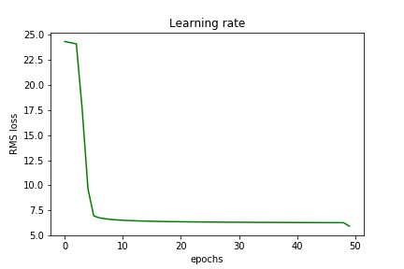

1. Training RMS Error: 7.7
2. Test RMS Error: 6.2
3. Regression Result with training labels

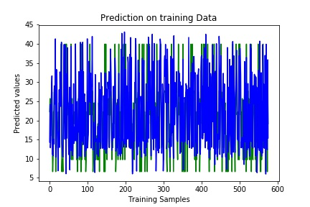

1. Regression Result with test labels

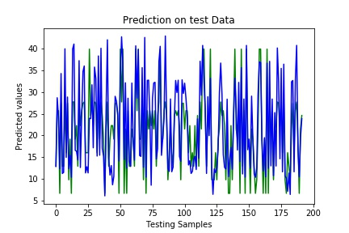

(c) The features are selected based on the correlation with the heating loading. The features which have positive correlation with heating loading will help to predict better result. The surface area and roof area have negative correlation with the heating loading. Therefore, these features are removed from model. The rest of 15 features are used for building regression model.

1. **Classification using Neural Network with one Hidden layer**
2. The training set and testing set created by randomly assigning 80% data samples to training set and 20% data samples to testing set.

Model parameters:

Epochs =390

Learning Rate = 0.03

Batch size=64

Network architecture: 34-10-1

Error function: Cross Entropy

Activate function: Sigmoid

b)

1. Neural Network Architecture (Every input xi is connected to every neuron ai of hidden layer-1 i.e. fully connected layer. The same assumption is true for out layer).

Input Layer Hidden Layer-1

X1

X2

X3

X4

X5

X6

X7

.

.

X34

a1

a2

a3

a4

a5

a6

.

.

a10

Output Layer Loss

Cross-Entropy

a1

1. Learning Curve

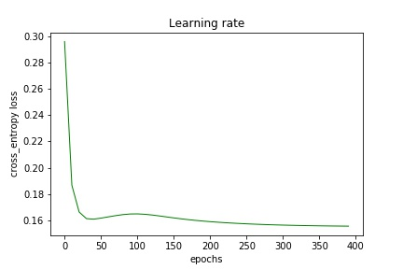

Train error rate: 0.15

Train Accuracy: 0.94

Test error rate: 0.10

Test Accuracy: 0.81

(c)

* Ttraining data samples = 280
* Batch size =16
* Division of training data sample 16*17.5=280

**2D plots:**

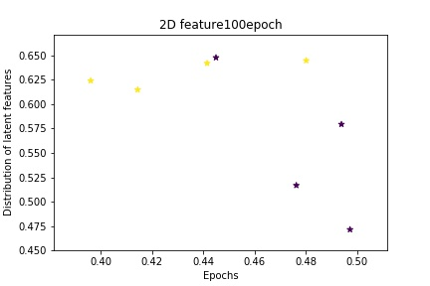

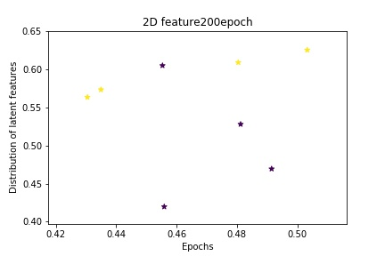

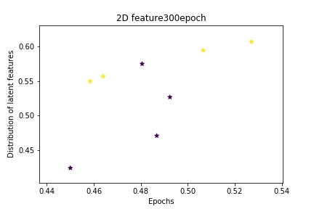

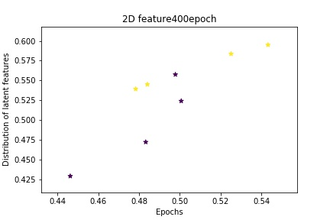

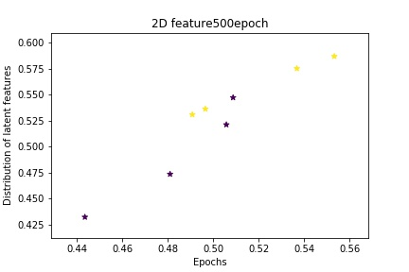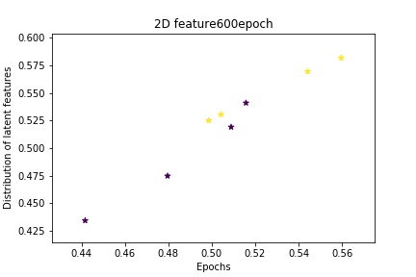

**3D Plots:**

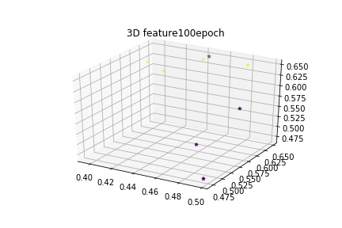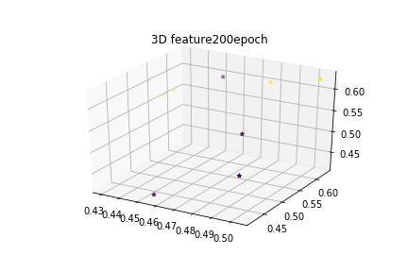

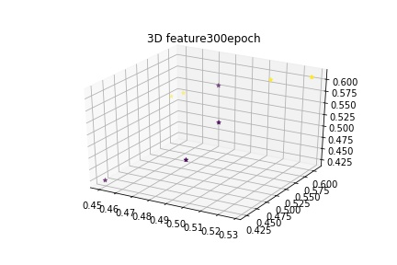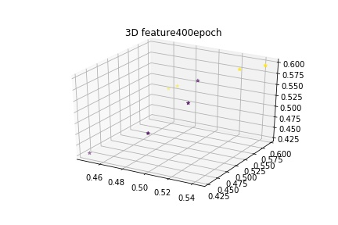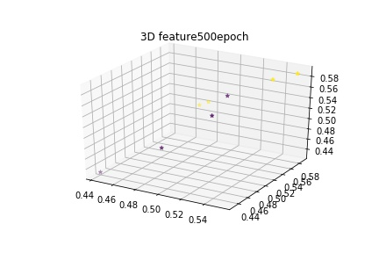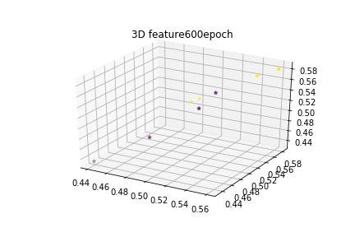

**Reference to plots:**

**https://stackoverflow.com/questions/17411940/matplotlib-scatter-plot-legend**